Preface
Thank you for purchasing our YZ11D Direct Ophthalmoscope. Please read this manual carefully for the sake of your best use.
General Requirements for Safety
Please read carefully about following precautions to avoid unexp¬ected personal injury as well as the product being damaged and other possible dangers.
Precautions
1. Do not use this instrument in the environment prone to fire and blast or where there is much dust and with high temperature. Use it in the room and simultaneously be careful to keep it clean and dry.
2. Only use fuse according to the specifications and ratings stipulated by our product.
3. Use the power cable supplied with this instrument.
4. Turn off the main power first before changing the bulb and fuse.
5. Turn off the power when it is not in use.
6. In case there is any trouble, please first refer to the trouble shooting guide. If it still can't work, please contact the authorized distributor or our Repair Department.
THE SAFETY MARKS USED IN THIS INSTRUMENT:
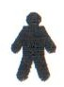 | 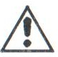 | 
Type B | Attention Please Refer to This Manual | class II

1. Nomenclature
1.1 The diagrams of the parts:
A Head
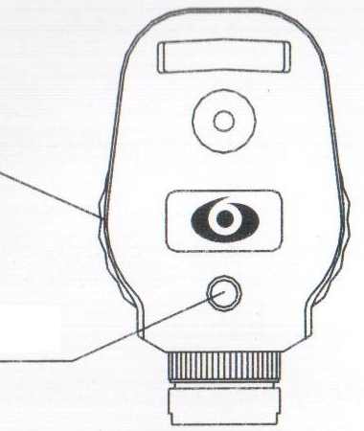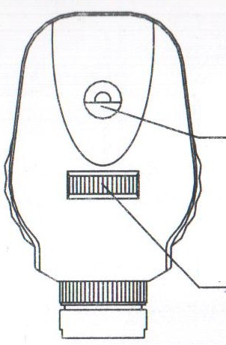
B Bulb
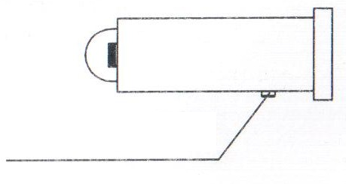
C Handle
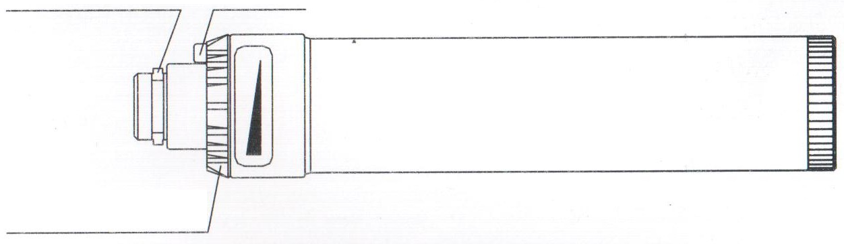
D Rechargeable batteries
E.Charging Unit
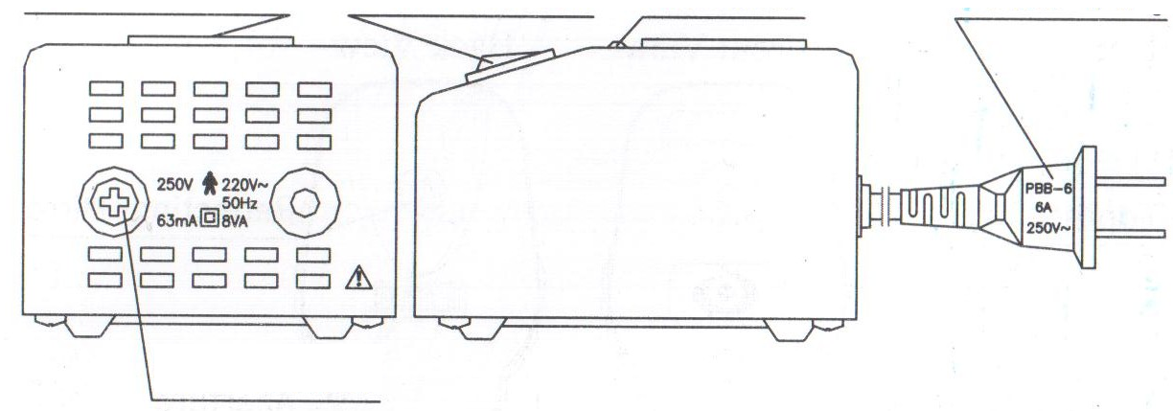
F Battery Cap(blue) for dry cells | G Battery Cap (red) for rechargeable batteries | H Protector
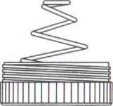 | 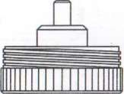 | 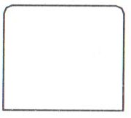

1.2 Nomenclature
A Head B Bulb C Handle D Batteries(Rechargeable Batteries) E Charging unit F Battery Cap(blue) H Battery Cap (red) G Protector
2. Assembly
This section of the manual describes how to assemble YZ11D Ophthalmoscope. All parts should be taken out with great care from the packing case before assembling.
2.1 Components
A Head B Bulb C Handle D Batteries(Rechargeable Batteries) E Charging unit F Battery Cap(blue) H Battery Cap (red) G Protector
2.2 Assembly procedure
Align the position tab on the handle with the groove in the head, then push the handle into the head and rotate clockwise.
3. Operation Procedures
3.1 The Selection of the Viewing Lenses
In this instrument the lens tracks comprises 24 lenses as follower:
0- +1, +2> +3« +4s +5, +6, +8, +10, +12, +16, +20D. Anticlockwise, black color.
0, -1. -2, -3. -4, -5> -6, -8, -10, -16« -20, -25, -35D. Clockwise, red color.
If necessary, please select the right viewing lens. The numbers of them are illuminated by light and can be read from the reading window.
3.2 The selection of the Spot, Slit, Central net and Red-free Filter
In this instrument there are five spots or marks which can be selected (the projective values of each diaphragm and each watch mark on the eye ground is shown in Table 1).
1) Big spot: for checking the fundus with turbid media. For example, it will help search for the seam of the retina. In a mydriatic condition, wider vision can be obtained.
2) Small spot: for general examination.
3) Slit: for examining the pathological changes such as the depressed optic nerve head and retinal edema.
4) Central net: for measuring the position of the foreign body and the field of the nidus. Also to examine whether the inspected eyes are out of center while watching.
5) Red-free filter: helps in examining the blood vessels in the fundus and its bleeding.
(The diagrams of the slit and the central net are shown as Fig 1 )
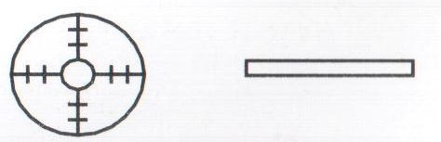
Fig 1
Table 1
Name |  | The | The diameter of the | The angle
 |  | diameter of | image of the spot | of the
 |  | spot(mm) | on the fundus(mm) | filed
Big spot |  | Ф 2 | Ф 3. 2 | 10° 34'
Small spot |  | Ф 1 | Ф 1. 6 | 5° 18'
Red free filter |  | Ф 1. 6 | Ф 2. 56 | 8° 36'
Central Net | interior | Ф 0. 4 | Ф 0. 64 | 2° 10'
Central Net | Circle 1 | Ф 0. 8 | Ф 1. 28 | 4° 19'
Central Net | Circle 2 | Ф 1. 2 | Ф 1. 92 | 6° 28'
Central Net | exterior | Ф 1. 6 | Ф 2. 56 | 8° 36'
Slit | length | Ф 2 | Ф 3. 2 | 10° 34'
Slit | wide | Ф 0. 2 | Ф 0. 32 | 1° 3'

3.3 On/off button and the Brightness Control
When use YZ11D Ophthalmoscope, please press the green button on the handle and rotate the intensity knob clockwise until the maximum brightness. Otherwise rotate the intensity knob anti¬clockwise until the green button is jumped off.
Means rotating clockwise then the brightness is increasing.
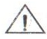Attention:
1) Ensure that the Ophthalmoscope is off when it isn't in use.
2) In order to prolong the life of the bulb, please don't make it be used in full state when the battery has just been charged.
3.4 Charging the Batteries
Put the batteries into the handle in line with the arrow, then cover it with cap covered in red. After that, insert the handle into the charging seat and. connect the power source then turn on the power. If the green indicator is on, it means the power is on. If the yellow one is on, it means in the state of charging. After finishing the charge, the yellow one will be off. If the charging unit is not in use, please turn off the power.
Attention:
1) The charging unit is intelligent controlled with the specialist stucture and no memorial effects.
2) When in clinic, the Ophthalmoscope may be recharged at once after use without exhausting all the power, which dose not have any effects on the Ophthalmoscope itself.
3) If you want to use it for a long time or use it outside, please continuously charge it at least two or three times to obtain maximum capacity. In additional, if the brightness is not enough,please charge it at once to prolong its life. If it is over-discharged, please charge/disch¬arge it several times then charge it continuously two or three times to recovery its maximum capacity.
4) When use the Ophthalmoscope at first time, please charge it continuously two or three times because it is in an uncharged condition before it leaves out of our company.
5) The shell of the handle is the connector, it must be kept clean. During the course of being charged for not enough brightness, if it is stopped within an hour, please pull the handle out of the charging unit and wipe it with neat cloth, then insert it again to continue charging. In normal conditions, it needs three hours to finish the charging.
6) If the Ophthalmoscope is not to be used for a long period,please discharge the battery and preserve it well.
7) Ensure that the on/off button is shut off when it is in the state of being charged.
4. Maintenance
4.1 Replacing the Illumination Bulb
1) Remove the head
After the bulb is cool, snap the head with one hand and hold the handle with the other hand, rotate the handle anticlockwise and pull the head out of the handle.
2) Pull out the used bulb with watch screw, then insert the new bu¬lb with the grove and the pin aligned.
3) To fit the handle, please refer to the 2.2.
4.2 Replacing the Batteries
1) Unscrew the dry cell cap and remove the used cells, replace wi¬th the rechargeable battery and screw the cap in red.
2) Similarly, unscrew the batteries cap and remove the used batteries, replace with two dry cells and screw the cap in blue.
Attention:
1) Ensure that the plus pole is upside while the minus is down and touched with the cap covered in blue when changing the dry cells.
2) When changing the battery, please insert the battery into the ha¬ndle in line with the arrow.
3) When not in use, please pull out the battery or the dry cells.
4) Remove the plastic isolation sleeve from handle when changing from dry cells to rechargeable batteries.
4.3 Replacing the Fuse
Turn off the power and pull out the power plug, then unscrew the fuse holder cap and replace with new fuse, then screw the cap.
The specification of the fuse is 250V 63mA.
Attention: Please select the fuse of the same type, specification and rating.
4.4 Cleaning
1) If any dust sticks on the reflecting mirrors, brush them with the brush. In case any dust still remains, wipe it off with soft cotton dipped with absolute alcohol.
2) If the surface of the Ophthalmoscope is not clean, please wipe it with soft cloth.
Attention:
1) Never scratch the reflecting mirror with fingers or any other hard materials.
2) Don't wipe with any corrosive detergent lest that the surface should be damaged.
4.5 Protection
1) The Ophthalmoscope should be in clean circumstance. If it is not used for a long period, it is recommended that it be put into the box in case of dust income.
2) The bottom of the handle should be clean to make the charging normal.
3) The hole for heat giving out should not be overlaid by everything possible lest the charging unit be broken.
4.6 Consumables
Please specify quantities when ordering consumables(bulbs or
fuses).
5. Trouble Shooting Guide
In case there is any trouble, please check according to the follow¬ing table for reference. If it still cannot work, please contact the Repair Department of 66 VISION TECH CO., LTD.or an authorized distributor.
Number | Trouble | Possible cause | Remedy
One | The bulb is not on | The button is not been pressed or not been rotated | Press the button and rotate clockwise
One | The bulb is not on | The bulb is burnt | Replace the bulb
Two | The brightness is not enough | The capacity of the batteries is not enough | Replace the batteries or charging them
Two | The brightness is not enough | The bulb is used | Replace the bulb
There | The green indictor of the charging unit is not on | The switch of the charging unit is on "off' | Place the switch on "on"
There | The green indictor of the charging unit is not on | The fuse is melt | Replace the fuse
Four | The fuse is melt | The fuse specification | Replace the fuse
Four | The fuse is melt | Is not right

6. Responsibility
We will supply the circuit diagram of the instrument, electric component list, drawing annotation and calibration details according to the customer's need for repair.
If (here is any need for inquiry of relative information and relative service or some questions, please contact with us directly or authorized distributors.
7. Transportation and Storage
1) Before leaving the company, the instrument has been well adjusted, please don't disassemble it anyway.
2) During the transportation, be careful to protect it from wetness, upside down and violent vibration.
3) This instrument should be stored in a well ventilated room without corrosive gas where the relative humidity should be 10% to 80% and environment temperature -40°C to 50°C .
8. Specifications
Illumination: 3.5V, 2.8W mini halogen bulb Recharging unit:
Input volt: 220V ± 10% V0 Input frequency: 50Hz ± 1Hz Input Power: 8 VA View Lenses:
0. ±1, +2, ±3. ±4. ±5. + 6. ±8, ± 10. +12. +16. ±20. -25. -35D
Illumination form: Large Spot, Small Spot, Slit, Central net and
Red-free Filter Net Weight: 118 g (excluding battery) Total Weight: 340 g Dimension: 42X32X210 (mm)
This instrument complies with Medical Electrical Equipment. Part I General Safety Standard. Class two Type B.

